MID-TERM REPORT

**Mini Project - II (2020-2021) “GEEK SEEK”**

# Synopsis



## Team Members:

Rohan Bhardwaj (University Roll No-181500589)

Shashank Kumar Pandey (University Roll No-181500654)

Shivani Chauhan (University Roll No-181500678)

Vanshika Mahle (University Roll No-181500781)

Vimal Mishra (University Roll No-181500792)

## Supervised By:

Mr. Anand Parkash Gupta Technical Trainer

Department of Computer Science Engineering & Applications

# Introduction of the Project:

Geek Seek is a full stack social network application for developers to be developed using Node.js, React, Redux, MongoDB, along with Express.

The platform will be developed in two parts – Front-end development and Back- end development. We will be building an extensive backend API using Node.js & Express and JWT will protect the endpoints. We will use Postman for testing our backend API and to handle requests. The front-end will be integrated with the backend in an elegant way to create a great workflow. For application state management, we will use Redux and create reducers and actions for our resources. Also, we will test our application using Redux Chrome extension. The application will be deployed to Heroku using Git.

# Technologies Used:

* MongoDB
* Express
* React
* Node.js
* Redux
* VS Code Editor
* JWT (JSON Web Tokens)
* Git
* Postman

**Objective:**

The project aims to build a full stack social network application for geeks which includes user authentication, user profiles and forum posts. The platform will be developed using MongoDB, Express, Node.js, Redux and React technologies.

The platform allows geeks to create their profile, update it or add additional details about them. They can also link their GitHub profiles by providing their GitHub username. The geeks can view profiles of other users and get connected with each other. They can post their views in the forum section, like other’s posts and put comments too.

# Features:

* New users can create a profile and register themselves
* Authentication for existing users
* Viewing profiles of geeks without logging in to the account and connect
* Add additional details to the profiles and edit them
* Link GitHub accounts by providing the GitHub username
* View five latest git repositories in the user profiles
* Add posts in the forum
* View and Like posts of other geeks
* Comment on the posts of other geeks

# Flow Diagram:

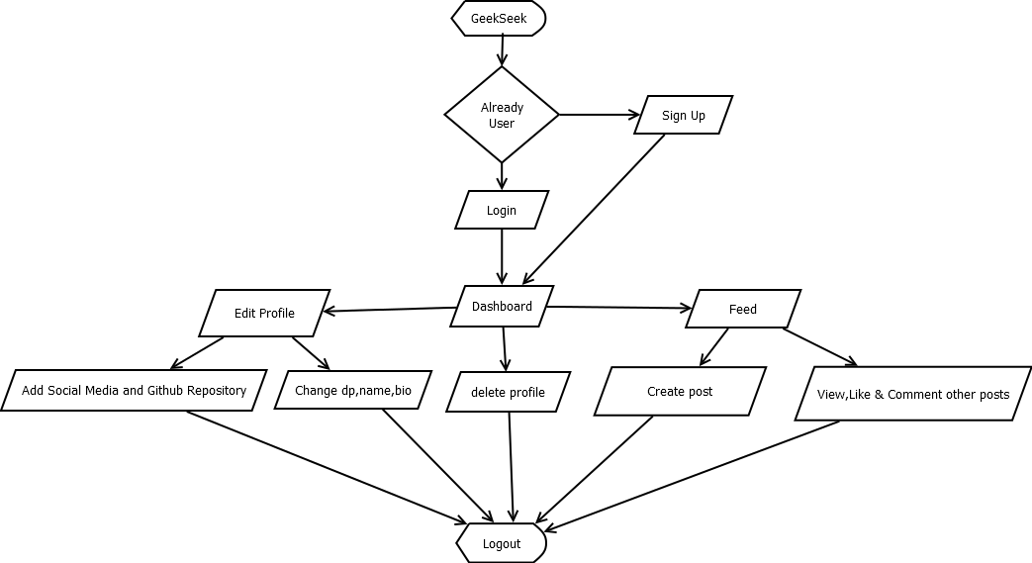

Backend-

We are testing are backend through Postman and Storing the data in mongoDB-Atalas(nosql cloud database).Currently we are able to register users through POST request and genearate a token So that they can edit their own profile through a POST request Moreover we are also able to view all the profiles as well as individual profile created in data base by a GET request.